**ORU_Glucommander_Cerner FlowSheets Requirements**

**Version 1.1**

**Prepared By: Lois Whitley & Tom Fredrickson**

**Date: 9/17/2019**

Document Control 3

Resources: 3

Document Version Control 3

1. Introduction 4

1.1 Purpose 4

1.2 Project Scope 4

1.3 Terminology Standards 4

1.3.1 Acronyms 4

1.3.2 Glossary 4

1.4 Document References 4

2. Diagram 5

3. Core Requirements 6

3.1 Cloverleaf Functional Requirements 6

3.2 Cerner FSI Functional Requirements 6

3.3 Non-Functional Requirements 7

3.4 Messaging Protocols 7

3.4.1 Protocol From or to Vendor 7

3.4.2 FSI Comm Server Names 7

4. HL7 Messaging 8

4.1 Messaging Format 8

4.1.1 Segments 8

4.1*.*2 Messaging Event Types 8

4.1*.*3 Cloverleaf Configuration Files 8

4.1.4 Cloverleaf Site Location 8

4.1.5 Cerner FSI Impacted Scripts 9

4.2 Data Transformation Requirements 9

4.3 Sample Message 9

4.3.1 Inbound to Cloverleaf 9

4.3.2 Outbound from Cloverleaf 10

5. Alerts 11

Appendix A: Risks, Concerns & Issues 11

# **Document Control**

## Resources:

Project Distribution List*:* (include Project Team Members, Liaisons, Vendor Contacts, etc.)

|  |  |  |
| --- | --- | --- |
| **Name** | **Role** | **Email** |
| Tom Fredrickson | Integration Analyst | [thomas.fredrickson@baycare.org](mailto:thomas.fredrickson@baycare.org) |
| Yitzhak Magoon | Integration Analyst | Yitzhak.Magoon@baycare.org |
| Deb McCracken | Manager, Clinical Systems, IS Application Owner / IS Liaison | Deborah.McCracken@baycare.org |
| Heather M. Doherty | BayCare Project Manager | Heather.Doherty@baycare.org |
| Rebecca Patterson | Glytec Systems Project Manager | rpatterson@glytecsystems.com |
| Allan S. Henderson | Glytec Systems Interface Engineer | ahenderson@glytecsystems.com |
|  |  |  |
|  |  |  |

## Document Version Control

|  |  |  |  |
| --- | --- | --- | --- |
| **Version** | **Date** | **Modifier** | **Description** |
| V1.0 | 9/13/2019 | Lois Whitley | Originally Created |
| V1.1 | 9/17/2019 | Tom Fredrickson | Added Technical specifications |
|  |  |  |  |
|  |  |  |  |

# 1. Introduction

## 1.1 Purpose

The purpose of this document is to describe the Results (ORU) interface from Glytec Glucommander to Cerner for incorporation into flowsheet functionality in Cerner. This interface transmits data elements specific to Glucommander treatment recommendations for both intravenous and subcutaneous insulin therapy.

## 1.2 Project Scope

The scope of this project is to automate the integration of the Glytec Glucommander application with Soarian via an HL7 ADT interface and the Cerner EMR via HL7 ADT and Results interfaces.

**The current document describes the ORU interface from Glucommander to Cerner Millennium for the purpose of charting in Cerner. Flowsheets will be built to display read-only dose update recommendations sent by Glucommander.**

.

## 1.3 Terminology Standards

### 1.3.1 Acronyms

ORU – Observation Result Unsolicited message

### 1.3.2 Glossary

Glytec – vendor name

Glucommander - software

## 1.4 Document References

Documents located on SharePoint in the Application Folder:

1. Technical Assessment Deck
2. Glytec Interface Planning and Implementation Guide_

# 2. Diagram

Provide a solution diagram that depicts the integration of components specified in this IDBB. This diagram must include the data flow for the interfaces (source and target).

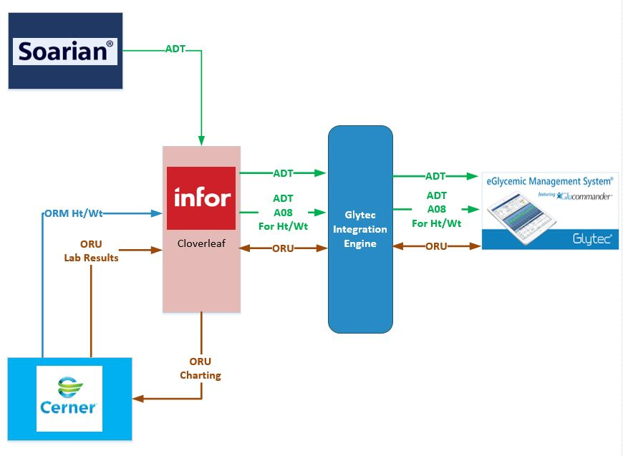

# 3. Core Requirements

## 3.1 Cloverleaf Functional Requirements

Provide detail for the below functional requirements. The message transformation requirements for the components defined in this specification should be specified in section 4.2 of this document.

|  |  |  |
| --- | --- | --- |
| **Cloverleaf** | | |
| **Number** | **Requirement Name** | **Description** |
| FR.2019.9.1 | If there is no CPI number kill the message. | If PID-2 Patient ID is blank, kill the message. |
| FR.2019.9.2 | Filter out invalid OBX segments. | Go thorugh all of the OBX segments and check if each has a valid OBX-3.1 oberservation identifier. If not remove the segment and reorder the count of segments. Valid oberservation identifier are configured in the lookup table: glytec_flowsheet_observation_identifiers.tbl  This is done in the tpsGlytecFlowSheetsToCerner proc. |
|  |  |  |
|  |  |  |
|  |  |  |
|  |  |  |
|  |  |  |
|  |  |  |

## 3.2 Cerner FSI Functional Requirements

|  |  |  |
| --- | --- | --- |
| **Cerner FSI** | | |
| **Number** | **Requirement Name** | **Description** |
| FR.2019.9.1 | Event Set Hierarchy | When the Contributor System is set to Event Code processing (in special config.) and there is ***NOT*** a consistent event code (OBX-3 value) that will always come inbound then you must create a DUMMY event code with the inbound alias that matches the OBR-4.1 alias    There is an Event Set Folder called **Glucommander Recommended** which contains the event code **Glucommander Recommended** which has an inbound alias (from code set 72) GLUCOMNDR_REC (seen in OBR-4.1) for Contributor Source Invision. This allows the aliased OBX result values to post in Powerchart (again aliased in code set 72) **IMPORATNT!!** Aliased OBX values will ***not*** post in Powerchart if the OBR-4 alias in ***not*** assigned as an inbound alias for an Event Code! Needs to be either a DUMMY (Glucommander) or Required Event Code (like GETWELL) |
| FR.2019.9.2 | Load Balancing | Load balancing is currently to PERSON_GROUP.PAT_GROUP.PID.PATIENT_ID_EXT.PAT_ID which is PID.2. If the patient’s CPI is not sent in PID.2 then the interface will crash. |
|  |  |  |
|  |  |  |
|  |  |  |
|  |  |  |
|  |  |  |
|  |  |  |

## 3.3 Non-Functional Requirements

Provide concise detail for the below non-functional requirements. This would include external table ownership, hours of support, etc. The below requirements must be evaluated for every project.

|  |  |  |
| --- | --- | --- |
| **Number** | **Requirement Name** | **Description** |
| NFR.2019.9.1 |  |  |
|  |  |  |
|  |  |  |
|  |  |  |
|  |  |  |

## 3.4 Messaging Protocols

Below are listed the details for the messaging protocols that will be leveraged for this integration. This includes: TCP/IP, FTP, Web Services, etc.

### 3.4.1 Protocol From or to Vendor

|  |  |
| --- | --- |
| FTP |  |
| MLLP Socket Connection (TCP/IP) |  |
| Local File Drop by Midrange Team |  |
| Other | Click here to enter text. |

### 3.4.2 FSI Comm Server Names

|  |  |
| --- | --- |
| Names | Click here to enter text. |
|  |  |

# 4. HL7 Messaging

## 4.1 Messaging Format

### 4.1.1 Segments

The segments utilized for this interface are:

MSH

PID

ORC

OBR

OBX

*Message Construction Notes:*

*[Square Brackets] – Optional*

*{Curly Brackets} – Repeatable*

*MSH – Message Header*

*PID – Patient ID segment*

*ORC – Common Order segment*

*OBR – Observation Request segment*

*OBX – Observation Result segment*

*[{ – Start of optional, repeatable group*

*}] – End of optional, repeatable group*

### 4.1*.*2 Messaging Event Types

Below are the messages types necessary for this integration

|  |  |
| --- | --- |
| **Event Type** | **Description** |
| ORU^R01 | Unsolicited transmission of an observation |

### 4.1*.*3 Cloverleaf Configuration Files

For each interface specified in Section 2 of this document, identify the Cloverleaf Configuration Files: Variants, TCL Scripts, Xlates, etc.

### 4.1.4 Cloverleaf Site Location

cerner_results_7_p

### 4.1.5 Cerner FSI Impacted Scripts

## 4.2 Data Transformation Requirements

| **Field Description** | **HL7 Field Loc.** | **Required R/O/C** | **Notes** | **Middleware (CL / FSI / Mule)** |
| --- | --- | --- | --- | --- |
| Message Header Segment | MSH |  | Path copy the entire segment | CL |
| Sending Application | MSH.3 |  | Hard code “GLUCOMMANDER | CL |
| Sending Facility | MSH.4 |  | Hard code “GLYTECSYSTEMS’ | CL |
| Receiving Application | MSH.5 |  | Hard code “CERNER” | CL |
| Patient Identification Segment | PID |  | Path copy the entire segment | CL |
| Common Order Segment | ORC |  | Path copy the entire segment | CL |
| Observation Request Segment | OBR |  | Path copy the entire segment | CL |
| Observation/Result Segment | OBX |  | Path copy entire segment. See CL FR.2019.9.2 | CL |

## 4.3 Sample Message

### 4.3.1 Inbound to Cloverleaf

MSH|^~\&|GLUCOMMANDER|GLYTECSYSTEMS|CERNER|SJ South Hospital|20190814094340||ORU^R01|f6151449-deda-43d8-957d-05461e0ebd03|T|2.5|

PID|1|^^^|M-892628187^^^||Meter^Max||19620523|M||||||||||022163935749474896^^^|

ORC|RE|9032|9032||||^RECOMMENDATIONS PER GLUCOMMANDER - IV&RECOMMENDATIONS PER GLUCOMMANDER - IV^^20190814011439^||20190814011439|

OBR|1|9032|9032|GLUCOMNDR_REC^GLUCOMMANDER RECOMMENDED|||20190814011439|||||||20190814011439||||||20190814011439|||||F|

OBX|1|ST|GLY101^BGID||9032|||||||||20190814011439|F

OBX|2|ST|GLY120^TARGET RANGE||120-160|mg/dL||||||||20190814011439|F

OBX|3|NM|GLY122^RATE||5.4|Units/Hour||||||||20190814011439|F

OBX|4|ST|GLY124^BG VALUE||>600|mg/dL||||||||20190814011439|F

OBX|5|DT|GLY127^NEXT BG AT||20190814031939|||||||||20190814011439|F

OBX|6|ST|GLY128^NURSE||SJS Nurse1|||||||||20190814011439|F

OBX|7|ST|GLY129^USERNAME||SJSNurse1|||||||||20190814011439|F

OBX|8|ST|GLY136^FACILITY||SJ South Hospital|||||||||20190814011439|F

OBX|9|ST|GLY138^UNIT||JS Emergency Department|||||||||20190814011439|F

### 4.3.2 Outbound from Cloverleaf

MSH|^~\&|GLUCOMMANDER|GLYTECSYSTEMS|CERNER|SJ South Hospital|20190814094340||ORU^R01|f6151449-deda-43d8-957d-05461e0ebd03|T|2.5|

PID|1|^^^|M-892628187^^^||Meter^Max||19620523|M||||||||||022163935749474896^^^|

ORC|RE|9032|9032||||^RECOMMENDATIONS PER GLUCOMMANDER - IV&RECOMMENDATIONS PER GLUCOMMANDER - IV^^20190814011439^||20190814011439|

OBR|1|9032|9032|GLUCOMNDR_REC^GLUCOMMANDER RECOMMENDED|||20190814011439|||||||20190814011439||||||20190814011439|||||F|

OBX|1|ST|GLY101^BGID||9032|||||||||20190814011439|F

OBX|2|ST|GLY120^TARGET RANGE||120-160|mg/dL||||||||20190814011439|F

OBX|3|NM|GLY122^RATE||5.4|Units/Hour||||||||20190814011439|F

OBX|4|ST|GLY124^BG VALUE||>600|mg/dL||||||||20190814011439|F

OBX|5|ST|GLY128^NURSE||SJS Nurse1|||||||||20190814011439|F

OBX|3|NM|GLY122^RATE||1.5|Units/Hour||||||||20190719115351|F

# 5. Alerts

Are you going to need alerting on this connection?

|  |  |
| --- | --- |
| Yes |  |
| No |  |

If the answer is yes, please complete the table below:

|  |  |  |  |
| --- | --- | --- | --- |
| **Site Name** | **Hours of Support** | **Distribution Group** | **Comments** |
|  |  |  |  |
| cerner_results_7_p | 24/7 | ISClinAppsPowerchartTeam@baycare.org | Primary: PowerChart team/Cerner Orders/Clin Doc  IS Application Owner / IS Liaison: Deb McCracken, Manager, Clinical Systems |

# Appendix A: Risks, Concerns & Issues

|  |  |  |  |
| --- | --- | --- | --- |
| **Project Name** | |  | |
| **Number** | **Risk/Concern/Issue** | **Comment** | **Mitigation** |
|  |  |  |  |
| RCI.2019.9.1 |  |  |  |
|  |  |  |  |
|  |  |  |  |
|  |  |  |  |

* End of document